Pos : 1
Fruit of the Loom Polo 0632140-white; 268 St.
Gr S-XXL

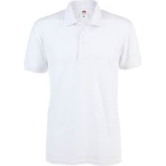

Pos : 2
Fruit of the Loom Polo 0632140-black 322 St.
Gr S-XXL

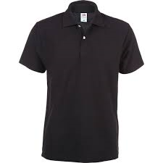

Pos : 3
Fruit of the Loom Polo 0632140-red; 277 St.
Gr S-XXL

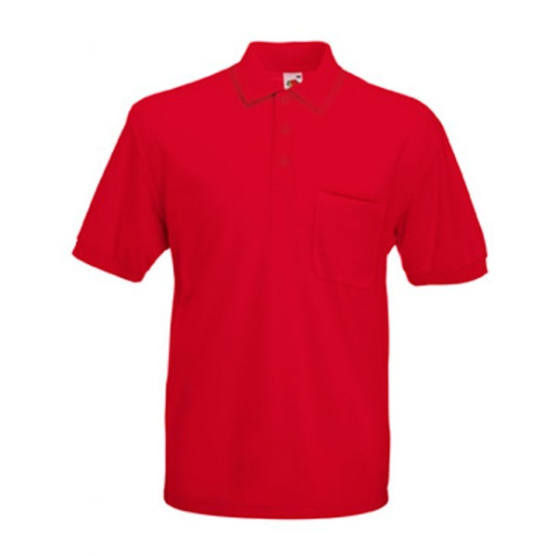

Pos : 4
Fruit of the Loom Polo 0632140-royalblue; 375 St.
Gr S-XXL

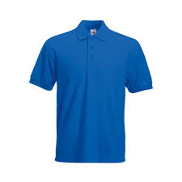

Pos : 5
Fruit of the Loom Polo 0632140-darkblue; 293 St.
Gr S-XXL

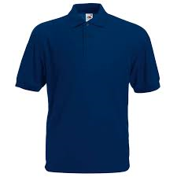

Pos : 6
Fruit of the Loom Polo 0632140-green; 267 St.
Gr S-XXL

